Pathway User Documentation:

Pre-requisites:

OpenCV: <http://docs.opencv.org/master/d5/de5/tutorial_py_setup_in_windows.html#gsc.tab=0>

Flask: <http://flask.pocoo.org/docs/0.10/installation/#installation>

Tileup: https://github.com/rktjmp/tileup

Image requirements:

.png format.

1080 x 1920 px image size (recommended).

Black and white (recommended).

Obstacles defined with solid colours.

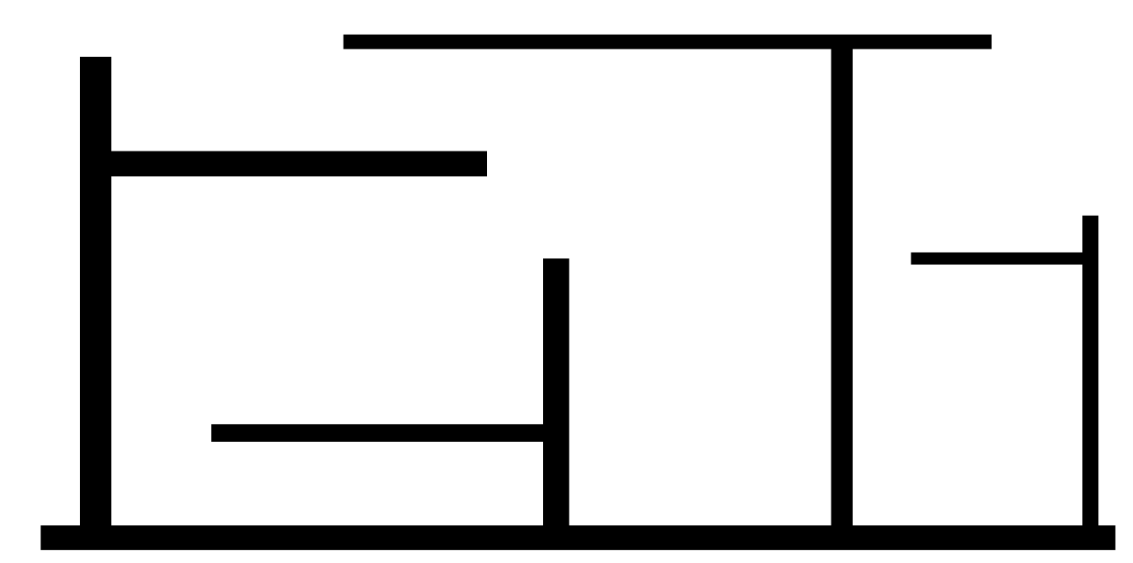

Figure 1: Example of a map that will work well with the application.

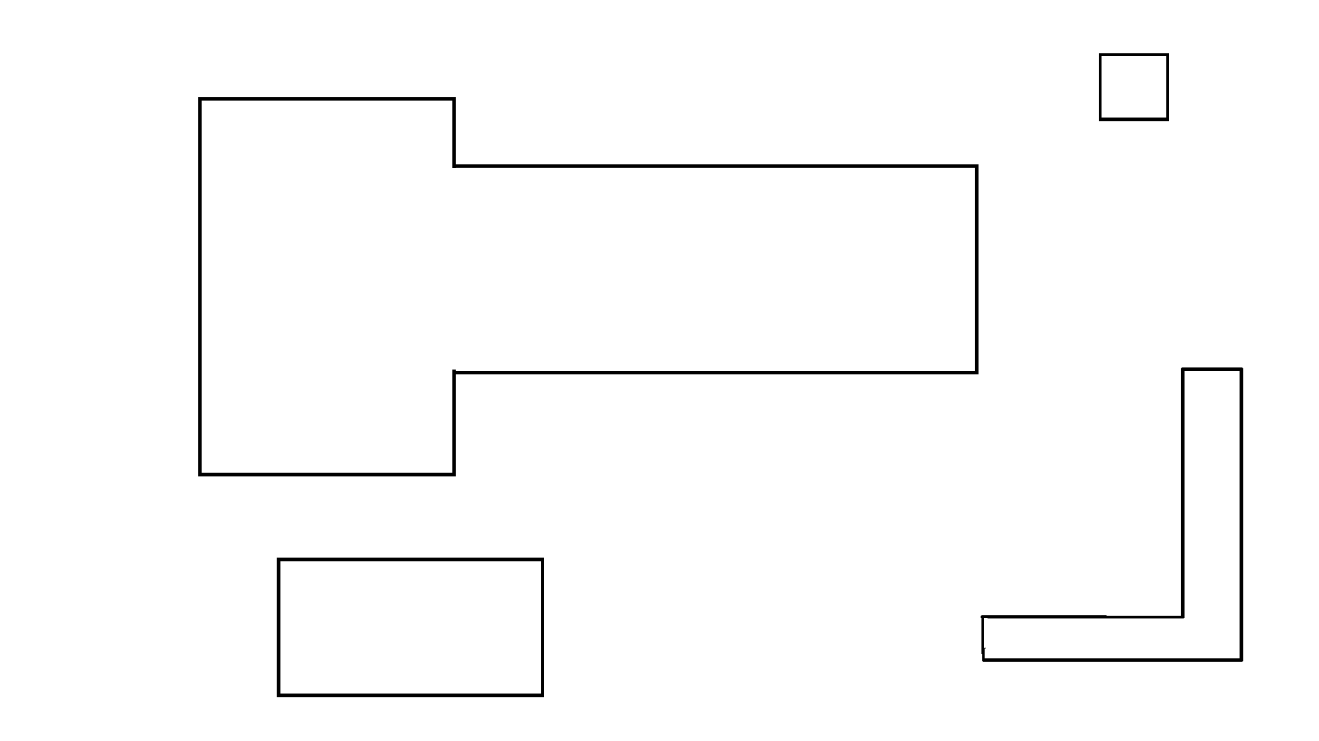

Figure 2: Example of an unsuitable map. The obstacles are wireframe in nature and the blank space will be incorrectly perceived as walkable space.

Introduction:

This application is used for efficient navigation through indoor environments. It can take in any properly formatted image as a map to work with, processing it through an obstacle detection algorithm. It then uses a path-finding algorithm to trace the shortest path between two user-defined points. This application is web-based in nature to allow for maximum accessibility between platforms.

Basic Use:

1. Run astar.py in terminal.
2. It will set up a local host for the user.
3. Type the name of the starting node and ending node. Nodes are named in the format of [c1, c2, c3].

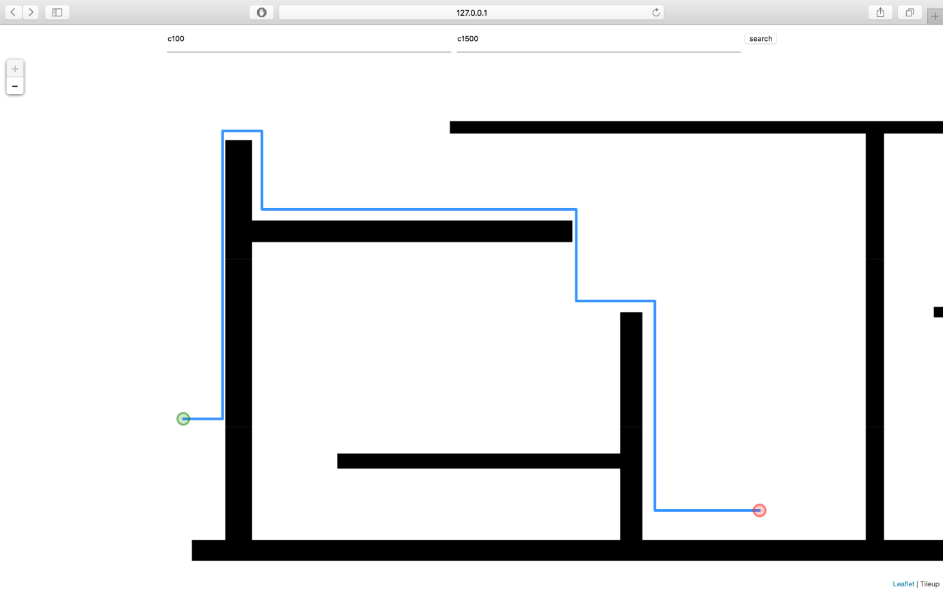

Type ending node here

Type starting node here

Figure 3: Finished result. Green node represents the start point and the red node represents the end point.